Template

Project Proposal Initiative [X]

If need for changes in the project proposal are identified, an updated project proposal is to be approved by FIPP according to due process.

Background Information
[Text from of concept paper on ‘Background information’ to be edited]

Purpose of the project
[State here what the initiative should achieve, the objective and sub-objectives and the reference to the SDP initiative]

Scope of the project
[State here what the initiative/project covers, also state what it does not cover. If identified also indicate different stages.]

Approach
[State how the project team plans to achieve the purpose within the scope.
Also: How will the coordination and approval process between projects be managed?]
[State how the identified dependencies between the projects; including input from other projects and the output required for other projects, coordination and approval process between projects will be managed. This should be aligned with the broader SDP 2023-2028 initiative.]

Key Risks and Quality processes
The quality process is two-fold:
- A quality consultancy within the relevant INTOSAI bodies (Subcommittees, working groups, IDI etc)
- The stages to involve FIPP according to Due Process

Consultation outside the INTOSAI
[State if the project finds it necessary to consult bodies outside of INTOSAI]
List also identified key risks that will require support from FIPP or other INTOSAI bodies

Deliverables and due process - milestone plan
Expected deliverables
There are both
- deliverables connected to the other SDP initiatives – internal and,
- deliverables according to due process, hereunder FIPP approval process
Deliverances could be divided into sub-deliverances when useful.
[State the different deliverables (sub-deliverables) the applicable process as defined in due process, interdependencies and quality control described earlier in the document and the planned timing;]
Type of Deliverance | With whom | Timing
Appendix
INTOSAI Due Process
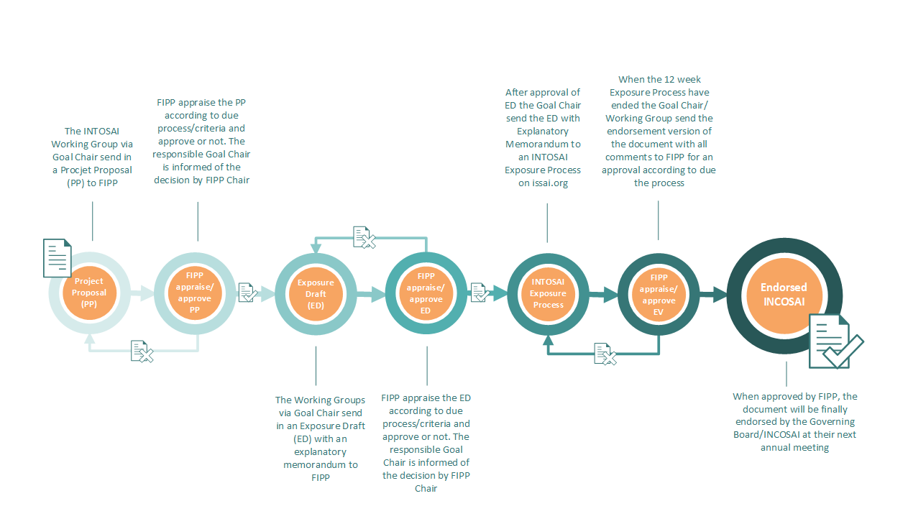

Due Process for the INTOSAI Framework of Professional Pronouncements
E.g. FIPP, INTOSAI bodies (sub-committees or similar) or bodies outside of INTOSAI, if necessary

