Strategic development plan for the INTOSAI Framework of Professional Pronouncements in 2023-2025
INTOSAI’s Strategic Plan for 2023-2028 focuses on five key organisational priorities and four strategic goals. Goal 1 is to “Develop, Advocate for and Maintain Professional Standards for SAIs”, which provides that:
“INTOSAI will support the effective functioning of SAIs in the public interest by providing, maintaining and advocating for internationally recognized professional principles, standards and guidance that promote the quality, excellence, credibility, independence, and relevance of public sector audits.”
This Strategic Development Plan (SDP), together with the operational plan for the Professional Standards Committee (PSC), aim to operationalise and support the achievement of INTOSAI Goal 1 through ongoing activities and specific initiatives. This overall aim is to develop the INTOSAI Framework of Professional Pronouncements (IFPP) towards a clear, consistent and relevant set of professional pronouncements. In doing so, assuring the professionalism and quality of the framework.
A framework of international standards is fundamental both for Supreme Audit Institutions (SAIs) and INTOSAI alike. For INTOSAI - reflecting its status as a professional standard setting organisation - the IFPP makes an important contribution to supporting the effective functioning of SAIs. For SAIs, the IFPP is important as a support for demonstrating the quality, excellence, credibility, independence, and relevance of public sector audits and other products anchored in their mandate. The IFPP is also a tool that helps SAIs underpin the value of their work, their accountability to the public, and to strengthen trust in their role and output.
The IFPP is also of benefit to parliaments, governments, auditees, academia and the public. It helps assure them that SAIs fulfil their mandate by applying a set of reputable principles and standards that are followed by the majority of SAIs around the world.

INTOSAI’s vision for developing the framework is:
To enhance the understandability and the recognition of the INTOSAI professional pronouncements both with SAIs and with external stakeholders
and thereby encourage increased and consistent application of the ISSAIs
leading to a global improvement in audit quality.

As the INTOSAI Strategic Plan covers the period 2023-2028, the vision and strategy for this SDP will be reviewed and updated in 2025, and if required, a new plan prepared for the period 2026-2028 taking into account progress made, developments in the audit profession and user feedback.
Part A of this SDP outlines the strategic initiatives that INTOSAI will pursue in updating and revising the IFPP.
Part B provides the work plan for 2023-2025 in the form of an overview of how the initiatives defined in part A will be organised in line with INTOSAI’s due process for the IFPP. This may include preparatory work as well as development of project proposals.

PART A – Strategy for developing the IFPP
In the late 2000s, INTOSAI developed a set of standards to improve audit quality in SAIs worldwide, known as the International Standards for Supreme audit institutions (ISSAI framework). Experience and feedback from SAIs led to the restructuring of the framework to improve its understandability and support its implementation. As a result, the framework was rearranged and changed its name from the ISSAI framework to the INTOSAI Framework of Professional Pronouncements (IFPP) in 2016.
The IFPP contains three main categories of pronouncements - The INTOSAI Principles (INTOSAI-Ps), International Standards for Supreme Audit Institutions (ISSAIs) and Guidance (GUIDs) – that serve different but complementary purposes:
- The INTOSAI Principles specify the role and functions, which SAIs should aspire to as well as prerequisites for its proper functioning and professional conduct;
- The ISSAIs is to set the principles and requirements governing different types of audits performed by SAIs; and
- The GUIDs support the implementation and practical use of the INTOSAI-Ps and ISSAIs.
This framework has been widely used by SAIs in different contexts and with different mandates. The various approaches for SAIs applying the ISSAIs is illustrated in Figure 1 below.

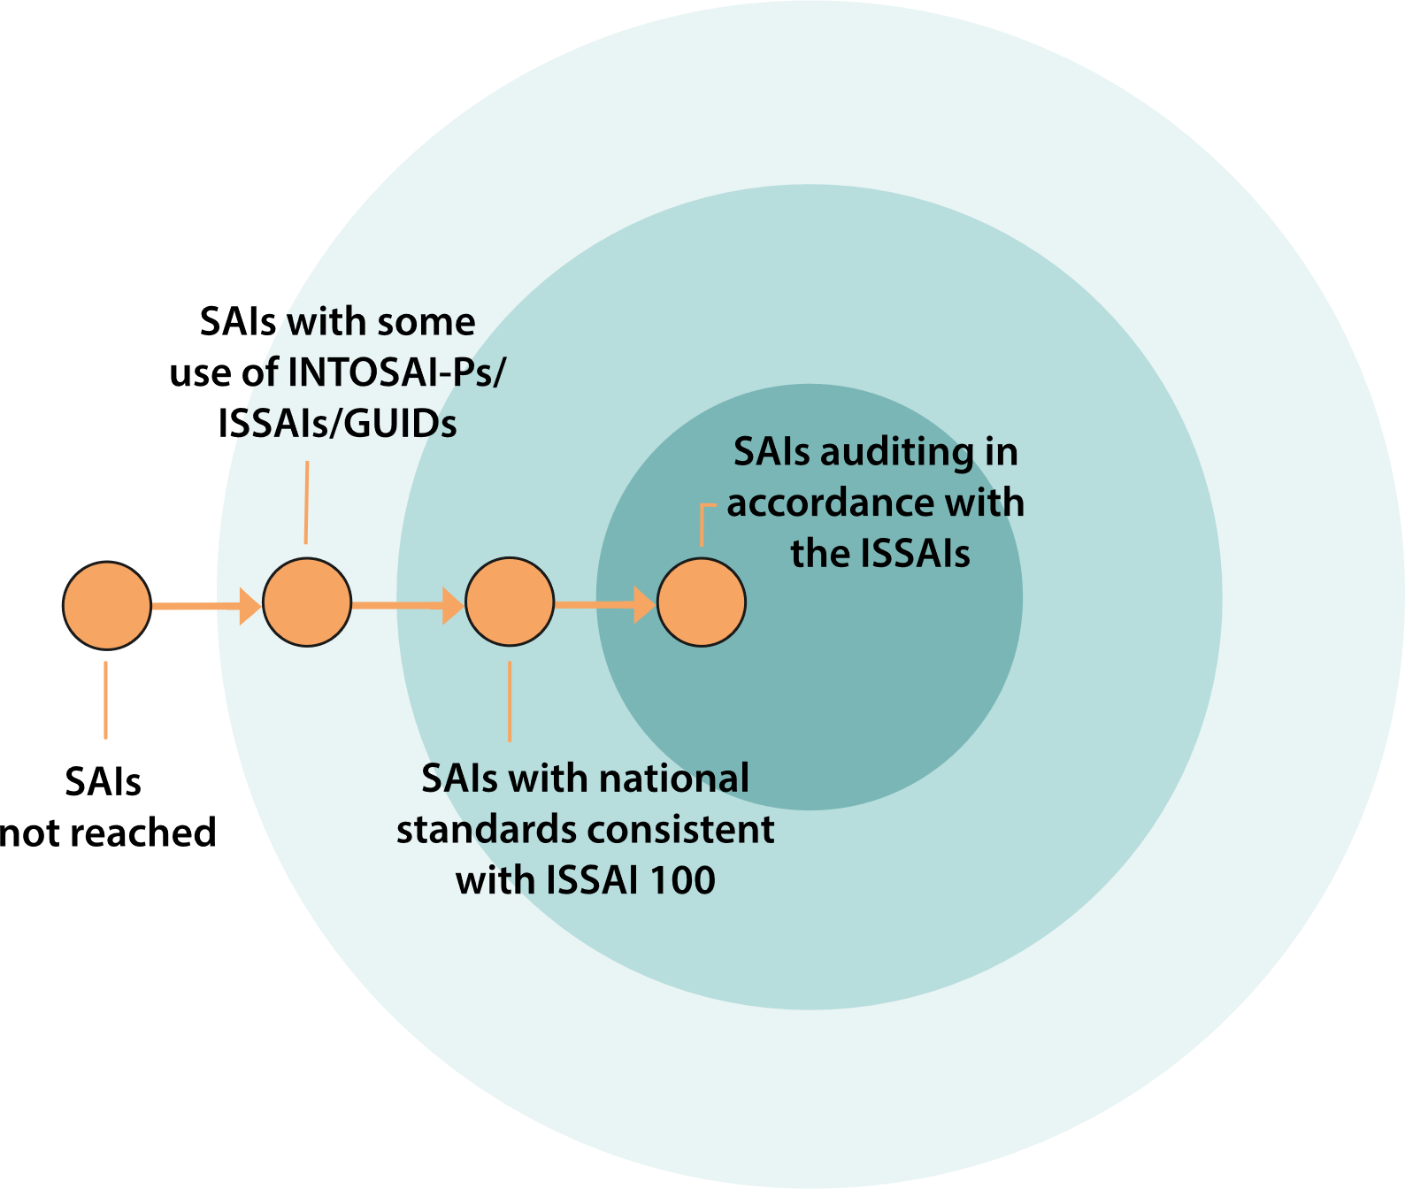
Figure 1: Various stages of SAIs applying the ISSAIs.

The overall ambition for INTOSAI is to encourage even more SAIs to apply the full set of ISSAIs and to do so more consistently. In 2020 a review was initiated by the PSC (INTOSAI Goal 1) to understand if and how the framework is implemented and to identify obstacles for implementation and compliance with the requirements (Component 1). The PSC’s final report review (the Final report on the review and analysis of the IFPP ) is available here: Final_Report_Review_Analysis_IFPP_Component_One_2022.pdf (psc-intosai.org).

Several sources of information from users of the IFPP indicate challenges in implementing the framework due to a lack of clarity. In addition to the review and analysis of the IFPP, the IDI Global SAI Stocktaking Report 2020 file (idi.no) concluded that three main and feedback from working bodies within INTOSAI engaged in standard setting.
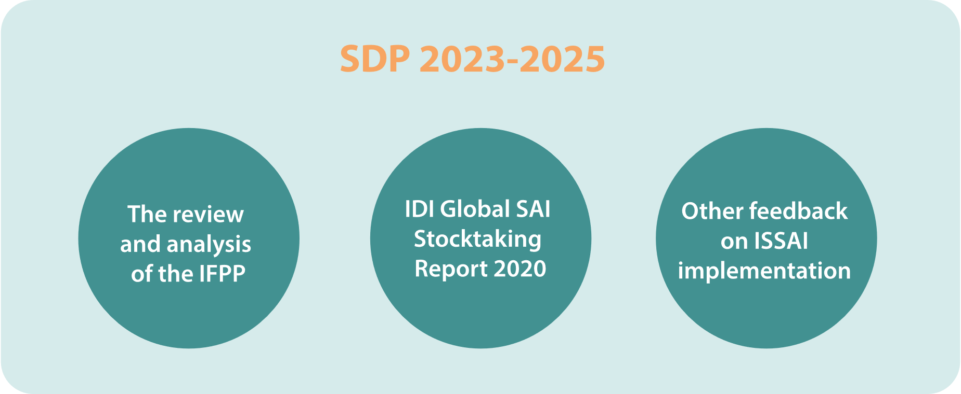
Figure 2: Sources used in the analysis for the SDP 2023-2025.
While challenges have been identified from the users’ perspective, new technological tools available provide opportunities for easy access to the pronouncements.
In order to increase the number of SAIs using the ISSAIs as their auditing standards, we believe addressing the challenges and developing a robust technical solution for the framework should be our main priority in the next SDP.
To facilitate global acceptance and application of the INTOSAI Ps and the ISSAIs, our primary aim is to follow a principles-based approach. In this way both the INTOSAI-Ps and the ISSAIs set out what should be achieved. The detailed description of how this could be achieved in practice is part of the supporting material. GUIDs – supplemented by other guidance in different forms – are application guidance for basic methodology and provide options that the SAI can choose from when developing their own methodology.

Strategic standard-setting initiatives for the way forward
The IDI Global SAI Stocktaking Report, the report on the review and analysis of the IFPP, feedback from users and consultations with key bodies involved in standard setting have identified a potential for improvement at various levels. At the same time, digitising provides new possibilities to improve accessibility.
The INTOSAI vision for the IFPP will be implemented through the following strategic initiatives:
- The ‘A’ initiative – Improving accessibility to the pronouncements.
- The ‘T’ initiative – Developing a clear and consistent terminology for the IFPP.
- The ‘P’ initiative – Updating the content and presentation of the INTOSAI Principles.
- The ‘I’ initiative – Ensuring clarity of the ISSAIs.
- The ‘G’ initiative – Developing a better approach to providing guidance.

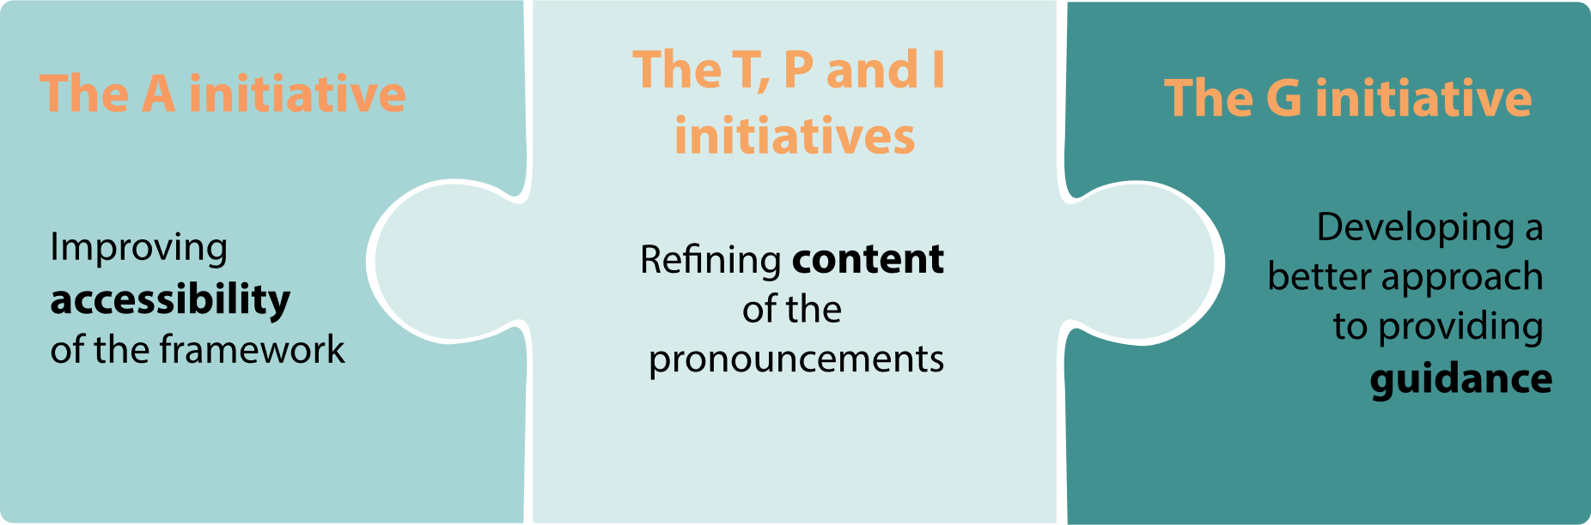
Figure 3: The initiatives and how they are interlinked.

Improving accessibility to the pronouncements (the ‘A’ initiative)
Accessibility of the framework is a key element in helping users approach the framework with confidence, and finding it intuitive to use. Digitising provides us with new opportunities to improve accessibility which can lead to a better understanding and more intensive use, and provide the users a more interactive way of accessing the pronouncements.
A digitised framework requires the development of terminology, updating of content and consideration of a more intuitive way to access the pronouncements. Therefore this initiative will be closely linked to the ‘T’ initiative (Developing a clear and consistent terminology for the IFPP) below. In the meantime, improvements will be made to IFPP website (issai.org) to address some of the challenges identified.
The ‘A’ initiative consists of two sub-initiatives:
- Short-term initiative: updating the issai.org website to make it more user-friendly and to refine the presentation of the pronouncements to underpin their current classification within the framework and their authority.
- Longer-term initiative: based on the development of terminology and definitions and following the other initiatives, to digitise the framework to allow its users to access content that suit their needs.
To ensure continuity for IFPP users and to allow for a best practice test-period with dedicated users common to it-projects in general of the digitalised framework, the current document-based framework will be applicable while the digital platform is being prepared, and for a transitionary period after it is approved for use and has proven its usefulness in practice.
The ambition for this ‘A’ initiative is to digitise the entire IFPP and to make its content more accessible for SAIs and auditors, and thereby for them to use the pronouncements more frequently.

The output of this ‘A’ initiative will be a full set of pronouncements that can be accessed in a more interactive way.

Developing a clear and consistent terminology for the IFPP (the ‘T’ initiative)
The INTOSAI pronouncements were developed over many years by different teams and working bodies. This has resulted in some inconsistent use of terminology, as well as outdated content. The individual pronouncements provide definitions of certain key terms but there is currently no consolidated glossary. In order to be able to clarify the content of ISSAIs and other pronouncements, a first important step is therefore to develop a clear and consistent terminology for the IFPP.
The ‘T’ initiative includes activities related to:
- Establishing a list of terms and definitions currently used in the IFPP;
- Based on that list, deciding on a consistent terminology that can be implemented in any subsequent development of pronouncements;
- Ensuring that the same matters are described in the same way while at the same time emphasizing the key differences between the audit types or other relevant circumstances.
The ambition for this ‘T’ initiative is to define the terminology that will be used in all future professional pronouncements and in updating the current ones. The terminology developed will be based on the concepts defined in ISSAI 100 Fundamental principles of public sector auditing and the additional concepts defined in other key pronouncements. This will include the professional language for different types of audits and steps in the audit process as well as the concepts used to define the authority of the ISSAIs and what it means to comply with them.

The output of this ‘T’ initiative is:
- a multilingual glossary of key terms for professional practice used within the IFPP;
- a set of language conventions that will provide the basis for all future development or revisions of content in the IFPP.
The ‘P’ (Updating the content and presentation of the INTOSAI Principles) and ‘I’ (Ensuring clarity of the ISSAIs) initiatives, as well as any development of GUIDs following the ‘G’ (Developing a better approach to providing guidance) initiative, can proceed in parallel, but should be mindful of the output of the ‘T’.

Updating the content and presentation of the INTOSAI Principles (the ‘P’ initiative)
The INTOSAI-Ps address the role and function, and set the principles that form the basis of the legal, institutional and organisational frameworks for SAIs. This is how the INTOSAI supports SAIs, legislators and governments in establishing relations, setting out the values and benefits of SAIs, and demonstrating their contribution to improving the overall system of public accountability.
The review and analysis of the IFPP identified a high degree of overlap between the INTOSAI-Ps, notably INTOSAI-P1 The Lima Declaration, INTOSAI-P 10 The Mexico Declaration on SAI Independence, INTOSAI-P 12 The Value and Benefits of Supreme Audit Institutions – making a difference to the lives of citizens and INTOSAI-P 20 Principles of Transparency and Accountability. There is therefore a need for consolidating these important documents into a clear set of INTOSAI Principles for the IFPP
The ambition for this ‘P’ initiative is to achieve a clear set of INTOSAI principles stemming from the current INTOSAI-P documents. The initiative will involve digitalisation and thereby serve as a ‘proof of concept’ for the ‘A’ (Improving accessibility to the pronouncements) initiative.
The ‘P’ initiative can be launched when the definitions of key terms relevant for INTOSAI-Ps under the ‘T’ (Developing a clear and consistent terminology for the IFPP) initiative is sufficiently advanced.
The output of this ‘P’ initiative will be a consolidated set of updated INTOSAI Principles for the IFPP, presented in a way that is easily accessible for users both inside and outside INTOSAI.

Ensuring clarity of the ISSAIs (the ‘I’ initiative)
The ISSAIs are the authoritative international standards on public sector auditing. They provide the professional concepts for defining different types of audits. The ISSAIs serve SAIs and other public sector auditors as a way to produce high quality work and assure users they can rely on the results.
The purpose of the ‘I’ initiative is to revise the ISSAIs to implement the terminology and language conventions resulting from the ‘T’ (Developing a clear and consistent terminology for the IFPP) initiative. This includes activities to:
- identifying text that could be used across the full set of ISSAIs to ensure clarity for users of the ISSAIs;
- identifying unnecessary repetition through the framework and ensuring consistency by describing the same matters in the same way, while at the same time emphasising the key differences between the audit types; and
- defining and distinguishing appropriately between auditing principles, requirements and application material.
The ambition of this ‘I’ initiative is to achieve a clear and understandable set of ISSAIs that can support both SAIs that are aiming for a full ISSAI compliance and for those who are in the process of implementing the IFPP principles.
The ‘I’ initiative can be launched when the ‘T’ (Developing a clear and consistent terminology for the IFPP) initiative has been completed and a sufficient robust organisation has been achieved to underpinning the standard-setting work. The ‘I’ initiative will involve a comprehensive revision of all ISSAIs.
The output of this ‘I’ initiative will be an updated set of ISSAIs.

Developing a better approach to providing guidance (the ‘G’ initiative)
Guidance in the form of GUID pronouncements supports the SAI in enhancing its performance related to the organisational requirements, development of competencies and ISSAI implementation. Through this guidance, the user finds support on how to apply the ISSAIs in the financial, performance or compliance audit processes and other engagements, and gets a better understanding of subject matter-specific issues.
The review and analysis of the IFPP, feedback from users and consultations with key bodies involved in standard setting showed that there is potential for improvement. This applies to the status and definition of guidance in its various forms within and outside the IFPP such as:
- the current inconsistent approach to presenting and making available guidance prepared by various INTOSAI bodies (including the IDI, INTOSAI regions, other groups etc.);
- the lengthy and complex process for including the GUIDs in the IFPP, which does not support a timely revision of existing - or development of new - material particularly when responding to urgent needs;
- insufficient clarity about the need for and format of guidance, notably when covering subject matter-linked material; and
- the audit methodology in a GUID is inconsistent with the audit methodology required by the ISSAIs.
The ambition of this ‘G’ is to ensure that the INTOSAI community has easy access to relevant and high quality guidance material regardless of the history of its development, and that guidance closely related to the implementation of the ISSAIs is refined to support SAIs implementing the standards. In addition the ambition is to encourage INTOSAI bodies and SAIs to develop and share guidance material as a manifestation of the mutual benefit this brings.
The output for this ‘G’ will be a set of recognised criteria for the nature of guidance that should be an integral part of the framework, and an appropriate due process for such material.

Prerequisites for these initiatives
A strategic objective in the INTOSAI Strategic Plan 2017-2022 was to provide a strong organizational framework to support INTOSAI’s standard setting including a permanent standard-setting board (the FIPP), a technical support function, and an independent advisory function. While this objective is to a large extent achieved, some further strengthening will be needed.
- Professionalised support
In order for the IFPP to be relevant to all SAIs regardless of size and context, standard setting must include auditors from a representative set of SAI contexts. Standard setting requires skills in both technical audit issues as well as in one or more of the official INTOSAI languages. This could potentially be an obstacle for many SAIs and prevent inclusiveness. To ensure strong involvement in standard setting, a more professionalised INTOSAI support function to assist in many aspects of the process including clear drafting, should be established. Such a supporting function would be instrumental in enabling wide engagement across the INTOSAI community, providing for enhanced transparency and collaboration in the process. The initiative will involve digitalisation and thereby serve as a ‘proof of concept’ for the ‘A’ (Improving accessibility to the pronouncements) initiative.
- Evaluations
The standard setting in INTOSAI involves the Goal Chairs and many working bodies. In order to deliver according to this plan, working together with open communication, is one key success factor. In addition, the launch of the strategic initiatives and projects to implement them depends on the availability of resources, as well as agile decisions on how bodies involved in standard setting – the working bodies of the PSC, CBC, KSC and the regions – would contribute. The collective endeavour in defining the projects and gathering of all viewpoints will be critical to the quality of project proposals as well as their implementation and subsequent completion.
The FIPP has a critical role in approving the project proposals as well as the outcome of the projects through due process. FIPP are also responsible for submitting proposals to the PSC Steering Committee on any changes in the overall scope and definitions of the IFPP (IFPP classification principles) as well as any future updates to strategy and workplan defined by this SDP.
The current challenges of clarity and consistency in the ISSAIs reflect the way INTOSAI’s standard-setting work has been organised in the past. It will be important to assure INTOSAI’s members and stakeholders that INTOSAI now has the reliable organisation and processes needed to carry out these revisions and achieve and maintain an improved set of standards. It is an important prerequisite for this SDP that INTOSAI continue to strengthen its standard-setting organization preferably through an external evaluation.
For more information of the organization and function, see Appendix 1.
Specific milestones and a timeframe will be set in the project proposals, the implementation of which will be monitored and reported upon by the PSC.

PART B - Workplan for 2023- 2025
Developed further after the invitation to comment is finalized.

Appendix 1:

Organization and function

Goal Committees
INTOSAI’s four goal committees focus respectively on professional standards, capacity development, knowledge sharing, and governance. The goal committees lead INTOSAI’s efforts under their respective goals and thereby assist the Governing Board in implementing INTOSAI’s goals and objectives. Approximately 25 subsidiary bodies contribute to the overall work of these committees.
INTOSAI’s technical work occurs in the committees, subcommittees, working groups, task forces, and communities of practice that are established to advance the profession. This is done by developing and issuing professional standards, audit guidance, and other practical reference materials, by sharing good practices in different formats, by organizing and engaging in professional dialogue and by encouraging an exchange of views and experiences to encourage innovation and development.
The Professional Standards Committee (PSC) leads the efforts to provide relevant and clear international standards and guidance for public sector auditing.
The Capacity Building Committee (CBC) is the INTOSAI advocate and custodian for SAI capacity development.
The Knowledge Sharing and Knowledge Services Committee (KSC) encourages SAI cooperation, collaboration and continuous improvement through knowledge development, knowledge sharing and knowledge services.
The Policy, Finance, and Administration Committee (PFAC) strives to maximize the value of INTOSAI both to its member SAIs and as an international organization.

Forum for INTOSAI Professional Pronouncements (FIPP)
FIPP is a forum of technical experts appointed by the Governing Board to address public sector auditing standard-setting issues. Operating in cooperation with the PSC, CBC and KSC, the FIPP has the general responsibilities for the content and quality of the professional pronouncements issued by INTOSAI. FIPP strengthens INTOSAI as an international standard setter and contributes to development of appropriate standards for public sector auditing.

The INTOSAI General Secretariat
The General Secretariat provides strategic and central administrative support to INTOSAI.
The tasks of the General Secretariat are amongst other:
- to maintain contact with and between members of INTOSAI in the periods between the Congresses;
- to assist the Governing Board and the Committees in the fulfilment of the tasks assigned to them and to promote the organization and coordination among the Regional Organizations;
- to organize symposia, studies and other activities promoting the aims of INTOSAI;

General Comments on the Draft SDP 2023-2025

SAI Algeria (Comment 70):
The wish to improve the quality of the standards is a good initiative, and the approach is part of a clear, precise and measured framework, favoring the participation of all the actors of the standard in its improvement both formally and materially. To this end, the FIPP framework also benefits parliaments, governments, auditees, universities and the public. This helps them ensure that SAIs fulfill their mandate by applying a reputable set of principles and standards that are followed by the majority of SAIs around the world.

SAI Argentina (Comment 71)
On behalf of our SAI we encourage the hard work you've been undertaking.
In this regard, we do not have any comments or suggestions to be included in the next SDP.

SAI Bahrain (Comment 72)
The suggested framework for the Strategic Development Plan for INTOSAI’s Professional Pronouncements is found to be practical and relevant to the SAIs’ current needs and reflects the challenges faced by and the feedback received from the users of the Professional Pronouncements in general. The focus on clarity and consistency is accurately addressing one of the major challenges faced by the INTOSAI Community, while improved accessibility is also crucial to improve compliance with the pronouncements. As some of the Guidelines within the framework are already outdated, we also agree with the need to have a more robust methodology and process for Guidelines to keep up with rapid changes in methodologies, technologies and subject matters.
However, the only concern is that major future changes in the structure and content of the INTOSAI’s Professional Pronouncements need to be carefully considered, as it would require more training and further procedures to ensure the users are updated and capable to comply with the professional pronouncements. Therefore, it is important to consider the subsequent effects, costs and benefits of the projects planned to be included in the Strategic Development Plan before launching them in the future.

SAI Denmark (Comment 73)
We would like to express our appreciation of the level of ambition of the plan, which reflects a sincere wish to improve the consistency and clarity of the pronouncements and, at the same time, make them more accessible.
However, the level of ambition is also what concerns us, particularly with respect to the timeframe laid down and the interdependence of some of the projects. Our concern is rooted in the strength of the current structure of INTOSAI’s standard setting which is to a large degree still dependent on contributing SAIs in key positions in the PSC and FIPP. In order to achieve the ambitions outlined by the SDP, we find it important that the initiatives are carried through in a way that also strengthens the common INTOSAI organisation in underpinning the standard-setting work.
We therefore find it highly important that the SDP recognises that it will require a strengthening of the support function as well as FIPP to achieve the SDP’s overall ambitions.
The role of the FIPP is to ensure that INTOSAI provides a clear and consistent set of professional pronouncements for public sector auditing. To ensure that the FIPP is in the best possible position to fill that role, we suggest that the initiative on terminology is given a high priority and a sufficiently long timeframe. This is to give FIPP and the support function sufficient time to organise a broad and inclusive process within INTOSAI as well as time to consider the technical matters that need to be solved in order to actually improve the terminology.
We also note that the SDP devotes little attention to the two types of auditing that distinguish public-sector auditing and the ISSAIs from ‘private sector’ auditing and other standards. We suggest that FIPP and the PSC Steering Committee consider if an additional initiative should be added on the development/compilation of a broader and deeper set of basic material on performance and compliance auditing. Developing material and/or guidance on performance and compliance auditing in the SDP is essential if INTOSAI wants in the longer run to be able to develop the ISSAIs further once existing inconsistencies have been solved.

SAI Kosovo (Comment 74)
I consider that Strategic development plan is clear, well-argued and promises progress in achieving goals through five key factors/initiatives. The shortcomings and challenges presented in this document are evident for many SAIs including SAI Kosovo. These challenges are indicators of the need for advancement and progress in IFPP initiatives.
In general, I agree with the initiatives A, T, P, I, G presented in this document and consider that these initiatives should be developed according to the proposal.
However, regarding the I and G initiative, I would like to emphasize my views that I hope will contribute a positive development.
During the implementation of these initiatives, I will point out the aspects that I consider should be taken into account:
- information technology audits, I consider that it should be clarified more through the I and G initiative. We currently have a Guide (5100) but more clarification is needed in the standards and guidance for these types of audits.
- the way of implementing ISSAI through guidelines and handbooks/manuals, I agree with the message from the workshops that the Guidelines should not be mandatory, however, the quality of the implementation of the standards depends on the implementation of the manuals and guidelines. So this should be kept in mind while all SAIs have similar mission.
Likewise, a clear program of continuous communication with SAIs (F2F) and monitoring and evaluation of the implementation of standards is necessary and ensures progress.
During the implementation of these initiatives, the technological developments should be taken into account, that is, the development of the strategy by leveraging technology.

SAI Morroco (Comment 75)
We consider that the draft SDP is comprehensive, objective and workable.

SAI Portugal (Comment 76)
As an overall comment, it´s our opinion that the prerequisites mentioned for these initiatives are appropriate and fit for their concrete execution/implementation.
In view of this, the Portuguese Court of Auditors (PCA) does not wish to suggest changes to the content of the above-mentioned document.

SAI Sweden (Comment 77)
A general comment that concerns several of the proposed projects is that it is of vital importance to maintain the three audit types. Their distinct characteristics need to be safeguarded and it should be easy to follow each process after the digitisation of the framework.

Compliance Audit Subcommittee (CAS) (Comment 83)
For the INTOSAI SDP being finalized, CAS had earlier proposed the development of a Guidance (GUID) on Scoping of Compliance Audits.
CAS Secretariat requests FIPP/ PSC to consider inclusion of the above proposed IFPP Project while finalizing the activities to be taken up in the next SDP. Since the SDP shall be formally adopted only by November 2023, the work on the same is expected to be initiated by the end of 2023.

FAAS Chair (Comment 78)
Thank you for the opportunity to review and comment on the proposed Strategic Development Plan (SDP) for the INTOSAI Framework of Professional Pronouncements (IFPP) for the period 2023 to 2025. This response reflects the views of the chair of FAAS.
In the past, the SDP seemed to remain strictly focused on the development of new pronouncements and we now observe that development activities related to improving the overall quality of the IFPP are prioritized. We agree with the inclusion of such priorities in the SDP for the period 2023 to 2025.
The activities of the Financial Audit and Accounting Subcommittee (FAAS) are controlled by the FAAS strategic and operational plans which are agreed upon by the FAAS group. FAAS ensures that its efforts always remain focused on helping the INTOSAI Professional Standards Committee (PSC) effectively achieve the Goal 1 strategic objectives which are defined in the INTOSAI strategic plan. The specific priorities of the FAAS group are presented in the FAAS operational plan.
At the time of this submission, FAAS is focused on the following priorities which FAAS has determined will lead to IFPP changes.
1.GUID 2900 - Guidance to the financial auditing standards is an IFPP pronouncement that requires annual maintenance due to its nature. The content of this GUID is directly linked to the financial audit
ISSAIs which are equivalent to the International Standards on Auditing (ISAs) developed by the International Auditing and Assurance Standards Board (IAASB). All changes to the financial audit ISSAIs must be carefully analyzed by FAAS to assess the impact on GUID 2900 and to initiate development activities when required.
a) FAAS has identified a need review the financial audit ISSAI content in Volume 1 of the IAASB handbook that was published on December 2, 2022 and to update GUID 2900 as required to ensure continued alignment of the guidance with the related standards. When performing this necessary review, FAAS may also propose revisions to help improve the overall quality of GUID 2900 when such opportunities for improvement are identified.
b) FAAS has identified a need to update Section 4 of GUID 2900 due to the changes to the quality standards developed by the IAASB.
c) FAAS has identified a need to update Section 27 of GUID 2900 due to changes that were made to ISSAI 2600.
2. FAAS continuously monitors changes occurring within the IFPP to determine if such changes have impacted the financial auditing pronouncements in the IFPP. FAAS is closely monitoring the ongoing development of ISSAI 140 to assess the impact on Section 4 of GUID 2900 and on related content in ISSAI 200 and ISSAI 2000.
FAAS is also monitoring the IAASB’s development of the new financial auditing standard for less complex entities to conclude on the relevance of this new standard to the public sector context. Since INTOSAI is presently aligning its financial auditing standards with those of the IAASB, a decision should be reached with respect to the treatment of this new standard in the IFPP.
Other current FAAS priorities could potentially lead to an IFPP development in the future and FAAS will inform those responsible for the management of INTOSAI’s standard-setting priorities whenever such conclusions are reached by FAAS.
Thank you for considering this information when establishing the SDP for the period 2023 to 2025.

Performance Audit Subcommittee (PAS) (Comment 79)
Thank you for the opportunity to provide comments on the draft SDP 2023 – 2025. The general consensus among Performance Audit Subcommittee (PAS) members is that albeit one of the more ambitious plans, the initiatives if achieved will improve clarity and understanding of the framework.
Before providing comments on the specifics of the draft SDP, PAS would like to propose an addition to the SDP. The PAS work plan includes a priority relating to undertaking scheduled maintenance of ISSAI 3000, Guid 3910 and Guid 3920. While the format and timing of this work is yet to be agreed with members, we would like the planned work to be included in the SDP.
General Comments
It is important that all work originating from the SDP is classed as a project and is clearly set out in a project plan, be it analysing the framework and making recommendations or updating a standard. Projects with clear proposals and clearly defined objectives will better inform PAS members as to what is required of them and the contributions we can make.
Given the remit of PAS it is assumed that we will have control over any part of the process that concerns or impacts ISSAI 300 and 3000. We are cognisant of the need for context where text is being recombined or omissions of sentences and terminology.
The reference to the status of INTOSAI as a ‘professional standard setting organisation’ (page
1) - INTOSAI has a wider remit in terms of capacity building, knowledge sharing etc… this wider remit could be included in order to demonstrate all aspects of the organisation.
Figure 1 (page 2) Various stages of SAIs applying the ISSAIs – As SAIs operate in very different circumstances and the capacities of SAIs differ, it would be helpful to explain what the target of ‘SAIs auditing in accordance with the ISSAIs’ (centre circle) looks like.
In relation to the sentence after the figure referring to SAIs applying the ‘full set’ of ISSAIs – the reference to ‘full set’ could be removed so as not to discourage those trying to apply the ISSAIs.
The prerequisites of professional support and evaluations
Professional support
In terms of establishing ‘a more professionalised INTOSAI support function to assist in…… drafting’, we would be interested to know how this would be resourced, funded, who would be responsible for recruiting for it and managing it, etc… INTOSAI as a voluntary organisation is driven by the voluntary efforts of its members which is reflective of the PAS subcommittee’s ethos. Should a support function requiring monetary funding be established, the implications on independence of INTOSAI must be well thought out and considered.
Evaluation of INTOSAIs standard setting organisation
Prior to considering an evaluation, INTOSAI key documents should be reviewed with a view to ensuring clarity and addressing discrepancies – an audit preparedness exercise if you will. However, the evaluation of INTOSAIs standard setting organisation is considered a perquisite to the initiatives. In terms of the evaluation, a number of key questions arise that must be considered and answered before proceeding – Who would carry out such an evaluation, what would be the expected outcomes and what if recommendations from it are at odds with INTOSAI as a voluntary organisation representing a diverse community?
New initiatives proposed
To help SAIs with the implementation of the ISSAIs and to support audit quality, the implementation of ISQM and of a risk based quality management system that integrates with the digitalisation of audit activities were noted. In terms of ways to help make the pronouncements available to auditors, producing them in Portuguese should be considered.
Comments on the initiatives
Before speaking to the individual initiatives, it is important that we are all cognisant of the risk of unintentional material changes that may not be surfaced through due process and that this is considered and mitigated against wherever possible. This is a concern in any process that is fragmented in nature
A initiative – improving accessibility
Not all SAIs will have the digital facilities to benefit from digitising the framework. Therefore, the maintenance and accessibility of the document based framework should be kept in view.
T initiative – developing clear and consistent terminology
This initiative should not result in equalising definitions of key financial audit, compliance audit and performance audit concepts as a goal in itself. Previous work conducted on the harmonisation project and the resources already available can be used as a starting point for this initiative.
P initiative – updating the content and presentation of the INTOSAI principles
Clarification is needed on the connection between the INTOSAI-P documents and the ISSAIs and if the Ps (in particular the declarations of Lima and Mexico) should remain in the framework. These documents are used by SAIs to promote their independence and may require ‘special status’ outside of the framework and as such will not be subject to revisions/updates in line with the requirements of the framework.
This initiative suggests the Ps will be subject to revision however it would seem logical to decide the positioning of the Ps within or outside of the framework prior to commencing this initiative.
The I initiative – ensuring clarity of the ISSAIs
There is a reference to the ISSAIs being the ‘authoritative’ standard on public sector auditing (page 5) – the framework is principles based and with the inclusion of the 100 series the word ‘authoritative’ should be removed. Over-harmonisation is not a goal in itself and differences can be intentional and reflect different specific features of an audit type.

